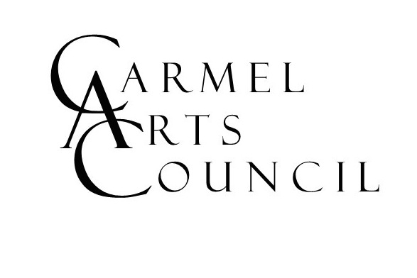
APPLICATION FOR GUILD MEMBERSHIP
(PLEASE PRINT)

Full Name: _________________________________________

Street Address: ________________________________________________________________

City: __________________________________ State: ____________ Zip: ____________

Phone: _______________ Occupation: ________________________________________

Please describe any experiences, memberships, or other skills/gifts that you believe would be beneficial to the Carmel Arts Council in considering your application.

Criminal Background Check Required.

As a nonprofit organization, the Carmel Arts Council and its members have direct and significant contact with the public, including children. You will need to provide a criminal background check to us to complete your application. Please use the following link to complete the check: www.in.gov/ai/appfiles/isp-lch/index.html

Please mail the completed application to Carmel Arts Council, P.O. Box 344, Carmel, IN 46082
You will be contacted by a board member to meet and discuss membership.

Membership Dues: $25 Annually
(pay online or check payable to “Carmel Arts Council”)

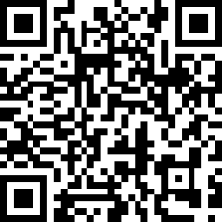

Signature: _________________________________ Date: ____________

The Carmel Arts Council sincerely thanks you for your interest! 2/22/2024 Revision

